How to setup the Database on a new PC (Fresh Install)

1. Download Git from <https://git-scm.com/download/win>
   1. Use the following settings as you go through the setup: Set the default editor to notepad, override the default branch name to be main, use git from command line and 3rd party software, use bundled OpenSSH, use native Windows Secure Channel Library, Use Checkout Windows-Style, use Windows default console window, use default behavior of git pull, use the git credential manager, enable file system caching, do not enable experimental features.
2. Go to the Desktop of the computer you are installing the database onto and right click to select open git bash here on windows 10 or open terminal here on windows 11 which should open a terminal window.
3. Type the following command  
     
   git clone <https://github.com/BYU-ME-PSC/BYU-ME-PSC-Database-V5.git>

If it asks for a login from the git credential manager login with email [mecheckout@gmail.com](mailto:mecheckout@gmail.com) and password MEpsc154. This should create a folder on the desktop containing all the database files.

1. Download PSQL ODBC from <https://www.postgresql.org/ftp/odbc/versions/msi/>
2. Create a System DSN
   1. Open ODBC Data Sources (32 bit) from windows search bar
   2. Select System DSN at the top
   3. Press add on the right side of the app
   4. Select PostgreSQL Unicode from the popup and press finish
   5. Fill the forms out as follows  
      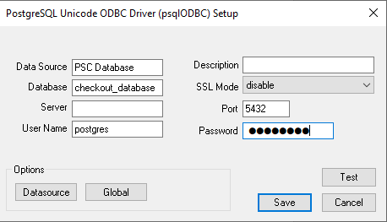  
      Where password is MEpsc154 and server is the IP address of the computer the PostgreSQL server is running on. The default port is 5432 but if that doesn’t work check if the computer running the server has set it as something else.
   6. Test the connection and if it is successful then save it.
3. In database main page right click on the border of the main screen to see the tab control options and go to the settings tab.
4. Change the reminder emails control value on or off and set that value as the default so it stays the same for that computer.
5. To get the atrium sales working uninstall any old versions of python, then install the newest python version from the Microsoft Store

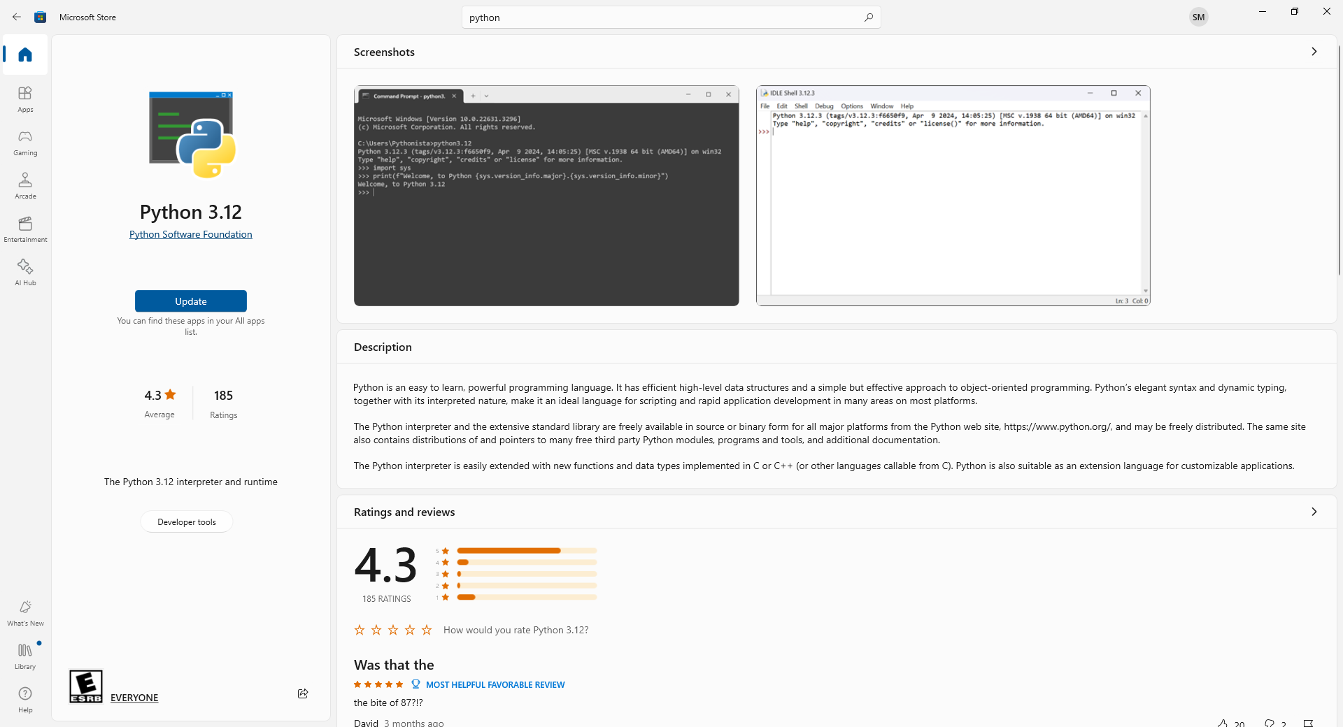

1. Open the Command Prompt as an admin and run the following commands:  
   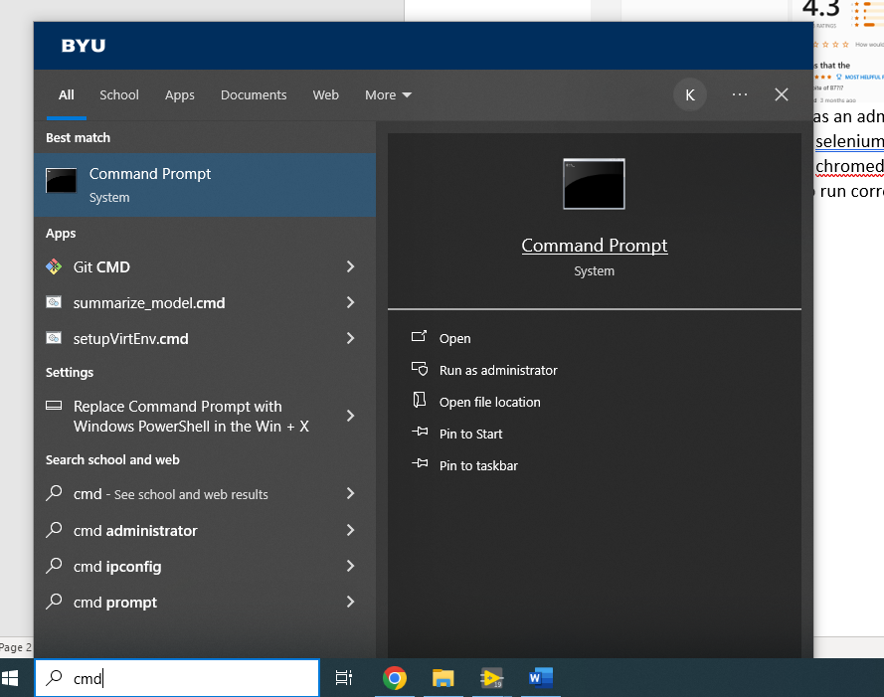
   1. python -m pip install selenium
   2. python -m pip install chromedriver-autoinstaller
2. The database is now setup to run correctly on that computer.

How to update the database with new changes from GitHub

1. Close all files related to the database and don’t save any of them if asked.
2. Open the folder on the desktop that contains the database and right click to select open git bash here on windows 10 or open terminal here on windows 11 which should open a terminal window.
3. Type the following commands in the terminal:
   1. git stash
   2. git stash clear
   3. git pull
4. Open the database project and main VI.
5. In database main page right click on the border of the main screen to see the tab control options and go to the settings tab.
6. Change the reminder emails control value on or off and set that value as the default so it stays the same for that computer.